Name: **Talha** | Roll number: **220989** | Lab 1 Assignment | BS AI

***[source code]***

*// including libraries*

*#include <iostream>*

*using namespace std;*

*// main function*

*int main(){*

*cout << "\t\t ______________________________________________________\n";*

*cout << "\t\t /\\_____________________________________________________|\n";*

*cout << "\t\t/ \\ |\n";*

*cout << "\t / \\ ____________________________ |\n";*

*cout << "\t / \\ | Sir Danish The Greatestest | |\n ";*

*cout << "\t / \\ ---------------------------- |\n ";*

*cout << "\t / \\ |\n ";*

*cout << "\t / \\ |\n ";*

*cout << "\t / \\ |\n";*

*cout << "\t /================\\=============================================|\n";*

*cout << "\t/| |\\ |\n";*

*cout << " / | | \\ \t|\n";*

*cout << "\t | | ____________ |\t\n";*

*cout << "\t | | | | | |\n";*

*cout << "\t | | | | | |\n";*

*cout << "\t | | |-----|-----| |\n";*

*cout << "\t | | | | | |\n";*

*cout << "\t | | |_____|_____| |\n";*

*cout << "\t | | |\n";*

*cout << "\t | | |\n";*

*cout << "\t |================|=============================================| \n";*

*return 0; }*

*[output]*

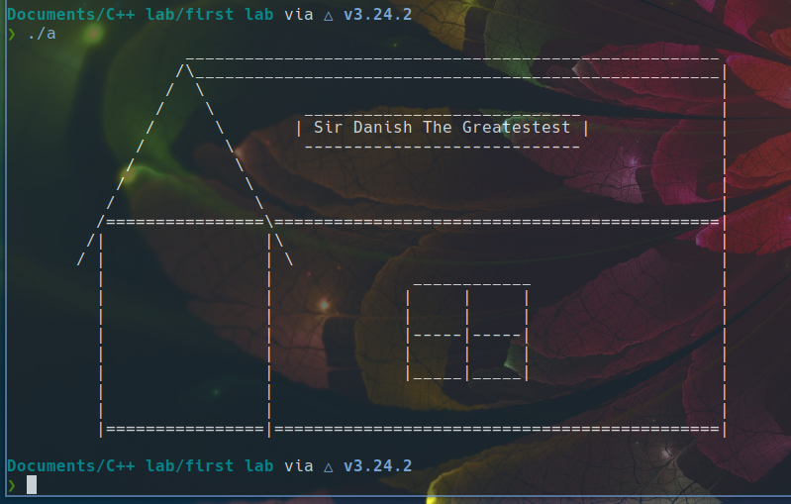***info***  **[**the above piece of code ran on **G++ compiler of version 12.2.0**, screen resolution of **1280x720** and text editor used for this purpose is **sublime-text-editor]**